Chaplaincy News

As we come to the end of the Christmas season I wanted to look back over Advent and Christmas at how we have prepared and celebrated as a school community. Here are just some of the things that been going on.

Forms took part in Advent Services (led by Form Tutors) where they placed advent symbols on our Chapel Jesse Tree. We used LED candles and music for a beautiful candle-lit service. Many forms also had their own Jesse trees.

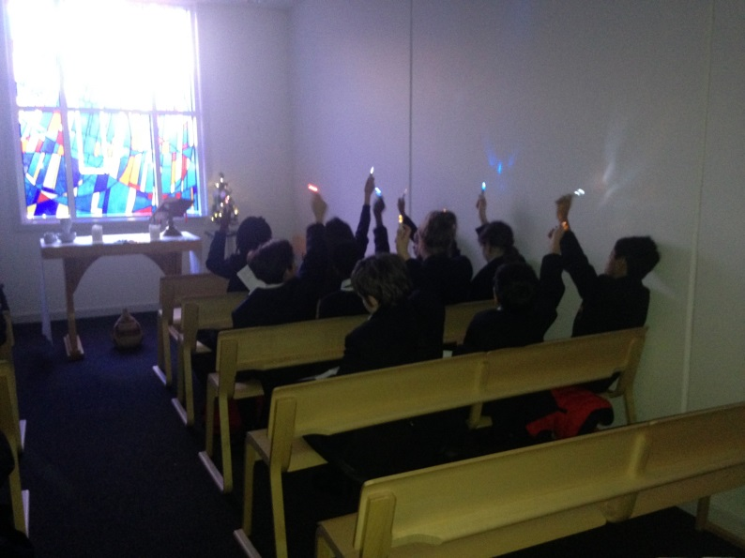

Some of the school’s Caritas Ambassadors decorated the Jesse Tree Symbols, ready for the services.

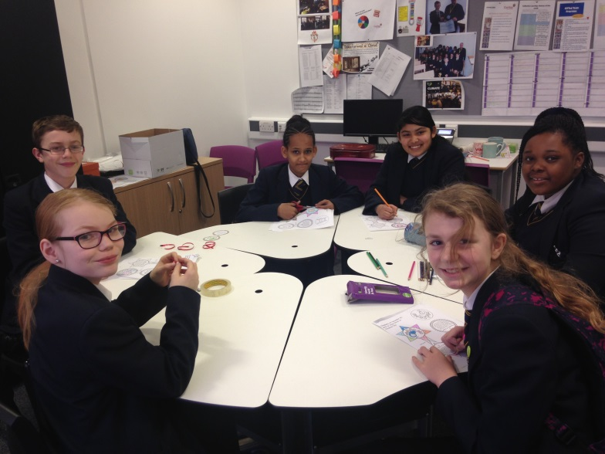

Our choir led a Carol Service at St James’ Church in Salford Precinct where pupils and staff gave up their time to help the parishioners of St James’ to enjoy Christmas Carols and also to raise money for the Caritas Cornerstone charity for the homeless.

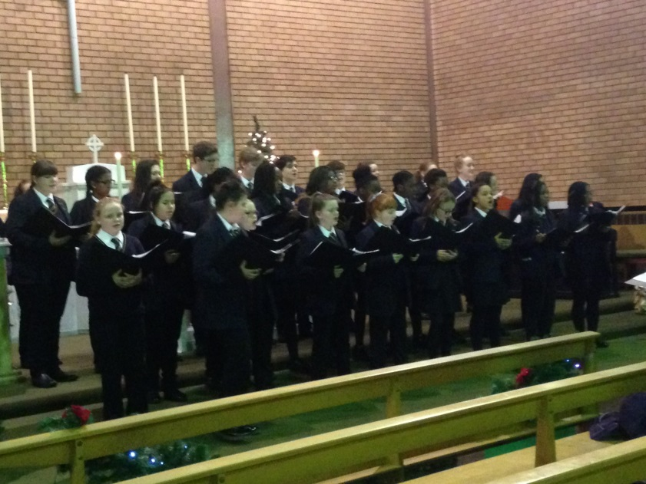

The choir also visited and sang for the patients and staff at St Ann’s Hospice.

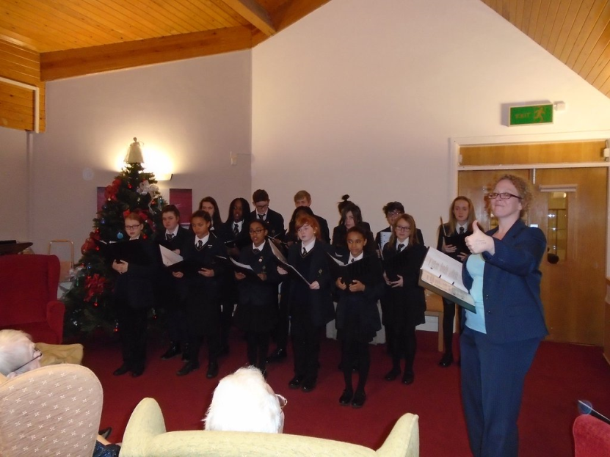

God has put into the hearts of so many people in our school community a desire to do good for other this advent and they responded.

Mrs Teasdale and the Dragon’s Den team have been selling Christmas gifts and have raised £1,700 for St Ann’s Hospice.

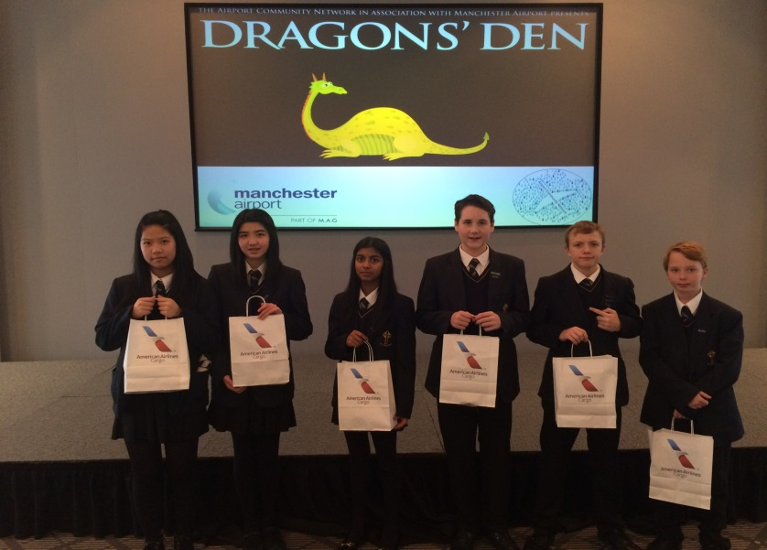

One of the activities that helped them to raise this money was the “elfies” photo booth stall.

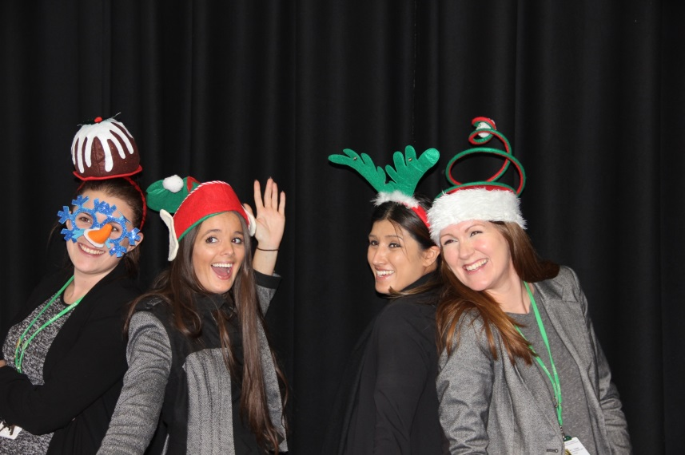

Everyone was entertained while they waited to have an elfie taken with Caroloke.

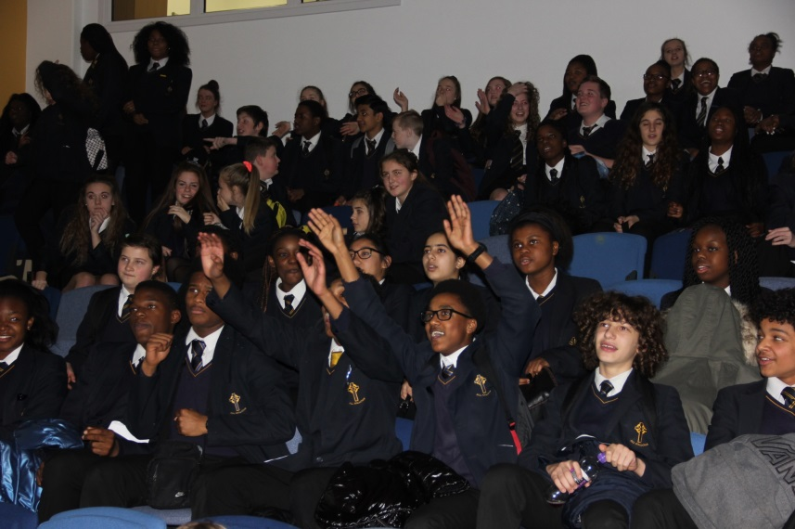

Mrs Murphy’s form raised money for charity with 2 competitions for guess the number of sweets and guess the number of lollipops.

Caritas Ambassadors helped Miss Hobin to launch the school’s response to the Key 103 Mission Christmas Toy Appeal and so many of you responded. For many, this will have meant going without something themselves or giving less to somebody who already has enough.



The school also collected food and toiletry donations for the Salford Loaves and Fishes Food Bank to help those who are struggling to afford to eat properly at Christmas.

Again, many of the people who have donated, may not have much themselves, but they are willing to share what they have. All who have donated have helped to improve somebody else’s Christmas. 

We have also reached out to the older members of our wider community, who might be lonely.

Twenty Five OAPs came to the school for a Christmas party and there were so many staff and students who contributed to the party that it was a real All Hallows Community event.

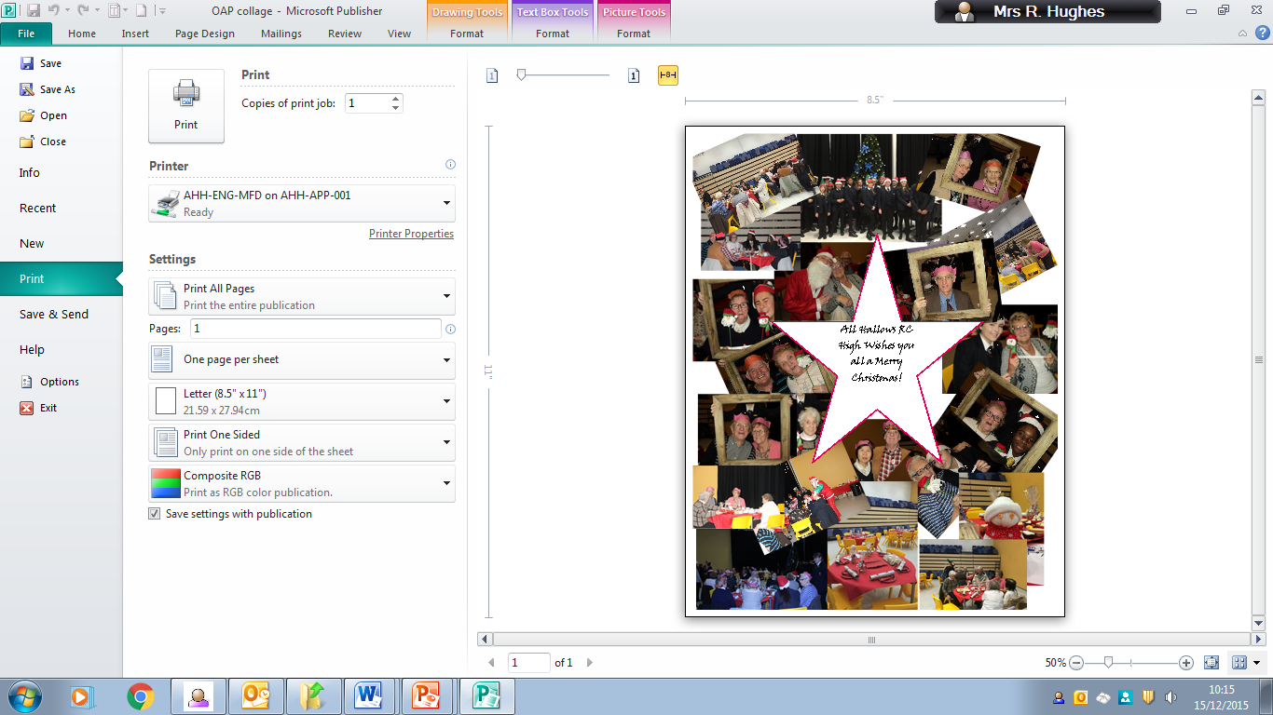

As a community we have prepared a welcome for Jesus during advent. We’ve done what he has told us to do:

“Then the King will say to the people on his right, ‘Come, you that are blessed by my Father! Come and possess the kingdom which has been prepared for you ever since the creation of the world. I was hungry and you fed me, thirsty and you gave me a drink; I was a stranger and you received me in your homes.” (Matthew’s Gospel).

When we came back to school, we were still in the Christmas season. The Transformation Team celebrated the Feast of the Epiphany by making Christingles and having a Christingle service.

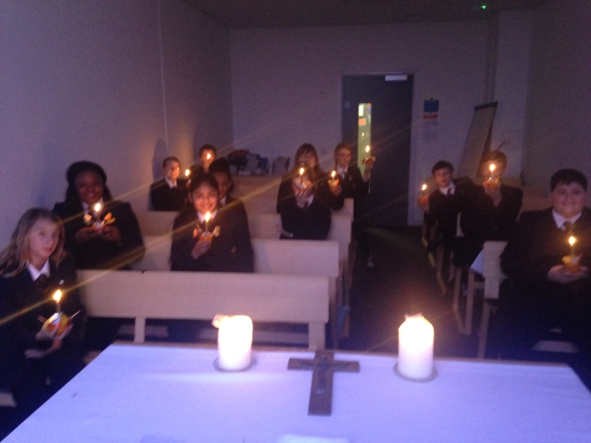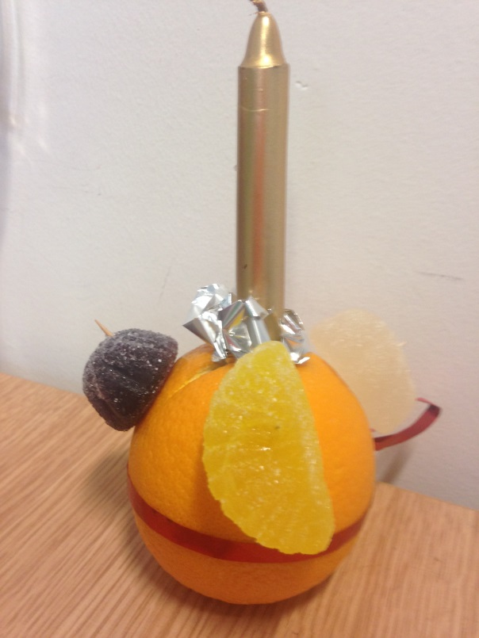

We are now in the Year of Mercy (launched on 8th December). In November it will be our school’s turn to host the Diocese’s Holy Door, which all of the pupils and staff will have an opportunity to walk through. Leading up to this event we will be preparing by having form-led paraliturgies and other events. Please check back soon to see how we are getting on.

With all the very best for the New Year,

Rachel Hughes

(School Lay Chaplain)