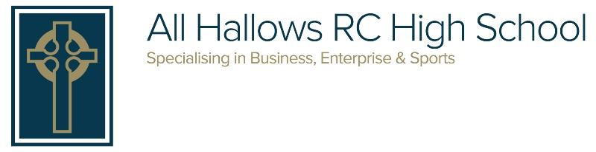
150 Eccles Old Road, Salford M6 8AATelephone: 0161 921 1900

E-mail: allhallows@salford.gov.uk Website: www.allhallowssalford.com

Headteacher: Mrs A. Cavanagh

Sunday 22nd March

Dear Parent/Carer,

I want to start by thanking all of you for your patience, support, kindness and understanding whilst we have worked quickly and tirelessly to respond to an ever-changing situation these last few weeks.

The children have been very mature and in good spirits; and the staff have been their usual amazing selves, ensuring that everyone is looked after, taught and is feeling safe. For Year 11, it felt like a rather abrupt halt to their time at All Hallows on Friday, and was emotional for us all - but this is not the end - we will come together as a whole year group later in the year, and will ensure that we celebrate in a Y11 leaver’s assembly, a Prom and the Presentation Evening, at the very least.

These are very unusual, in fact unprecedented, times and many people are making all sorts of sacrifices to ensure that this Covid-19 crisis is brought under control. The government, on Friday, announced extra measures (the closure of pubs etc.) with the absolute intention of significantly reducing the number of social contacts that we have with each other. Schools are closed (except for a few children) to aid this intention, and this means that you as parents, and our children - particularly the Year 11s - are also making sacrifices. It is, therefore, imperative that these sacrifices are not undermined by us failing to heed government instruction and advice. We are being told that, when not in school, children should be at home during this time, not out socialising or gathering in groups. When one is fit and well, young and feeling invincible, it may be difficult to take this situation as seriously as is required - but we are being asked to do this to protect other people (rather than just ourselves) who are vulnerable, such as the over 70s and those with underlying health conditions. The health minister has stated that by observing social distancing, and where required, self-isolation, we can literally save lives - so, we all have an opportunity to be heroes in our own small way. With God’s grace, we will all come through this together.

Opening next week
We are open from Monday 23rd March to the children of key workers (as defined by the government’s list) and to vulnerable pupils who we have identified and contacted. If your child does not fall into one of these groups, then they must NOT attend school. Even if your child does fall into one of these groups, the guidance from the government is that:-
many parents working in these critical sectors may be able to ensure that their child is kept at home. Every child who can be safely cared for at home should be.

This is to limit the chance of the virus spreading. It is absolutely correct that we support our key workers to continue to work where needed. We have planned for a set number of pupils based on our research and information gathered from parents and carers.

Pupils who attend school must wear full school uniform, and may additionally wish to carry a pair of trainers into school. Food will be available as normal on site. Pupils must not show any signs of illness and when attending are expected to follow our usual Code of Conduct. We will also require pupils to observe social distancing where practical, so they will not be gathering close together in groups or hugging!

Pupils will follow an amended timetable, which will include time to complete work set on google classroom, taught sessions, and some time for more creative, practical or relaxation tasks. Our planned day is 8:30 - 3pm. Pupils can arrive from 8am and attend breakfast club as normal. There will not be any extended provision at the end of the school day, so pupils will need to leave at 3pm.

Free school meals
Pupils who are attending school from Monday will receive a free school meal on site as normal. We are also funding food vouchers, which we will be delivering in person to families over the next few days.

Work packs
Pupils who were not in school on Thursday/Friday of last week have work packs in school. We will be endeavouring to deliver these to children’s homes over the next few days. This work is in addition to all of the online work (google classroom) that will be continuously and regularly set and marked by our teachers. This has been explained in more detail in my previous letters.

Working from home
Pupils who are working from home are advised to follow a routine, for the benefit of both their learning and their general wellbeing. We suggest that pupils follow their timetable as far as is practicable. They will be able to contact teachers through google classroom when needed, and during normal school hours, staff will endeavour to respond.

Communications
We would prefer communication (unless of a more urgent nature) to be via email. For more general enquires, please use allhallows@salford.gov.uk and for enquiries related to your child’s well-being or work etc., please use studentservices@allhallowsrc.co.uk. Both of these email addresses will be monitored during the school day, and you will receive a timely response.

Pastoral care and safeguarding
There will be key pastoral staff on site each day on a rota. Vulnerable pupils will be contacted by phone each week, or more regularly as required. If you have any pastoral concerns please email studentservices@allhallowsrc.co.uk, and a pastoral member of staff will get back to you. Safeguarding staff will be contactable throughout the week, and if you have any concerns of this nature, you should phone school. Please be assured that we are committed to the care and safety of your child and this will continue even during school closures.

Year 11 - exams and grades
On Friday the government released some further details on exams and grades via a press announcement. Full detail around processes and events have yet to be finalised, however, they have stated that:-
- Students will be awarded a grade which fairly reflects the work that they have put in.
- That there will also be an option to sit an exam early in the next academic year for students who wish to (if they are not satisfied with their awarded grade).
-Ofqual will develop and set out a process by which grades will be calculated, and that this will use a range of data, including, but not exclusively, teacher judgement.
- The aim is to provide grades before the end of July (this is subject to change), and grades given will be indistinguishable from those provided in other years.

We understand how distressing and confusing this time is for Y11 students, and so we welcome the fact that measures are being put in place to ensure that students are awarded the grades that they deserve. Please, however, be aware that any information requested by Ofqual from teachers will need to be unbiased and given freely and professionally. As such, teachers will NOT enter into any dialogue with students or parents about predicted grades.

Looking forward
I am an optimist by nature, and like you, I am looking forward to a time when all of this is behind us. A time when we can welcome our All Hallows’ family back into school and proceed with normality. Until then, I wish you and your family all the best for the coming weeks, and pray that you are safe and happy. I, like all of our staff, look forward to seeing our pupils again soon - we enjoy their vibrancy, working with them and watching them develop. In the meanwhile, please remember that we are here if you need us, and that you are uppermost in our thoughts.

God bless,

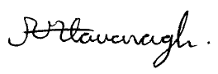

A Cavanagh
Head Teacher

