A to Z Guide for parents
2018
Visit our Website: www.allhallowssalford.com
Follow us on Twitter @AllHallowsRC
Email us: allhallows@salford.gov.uk

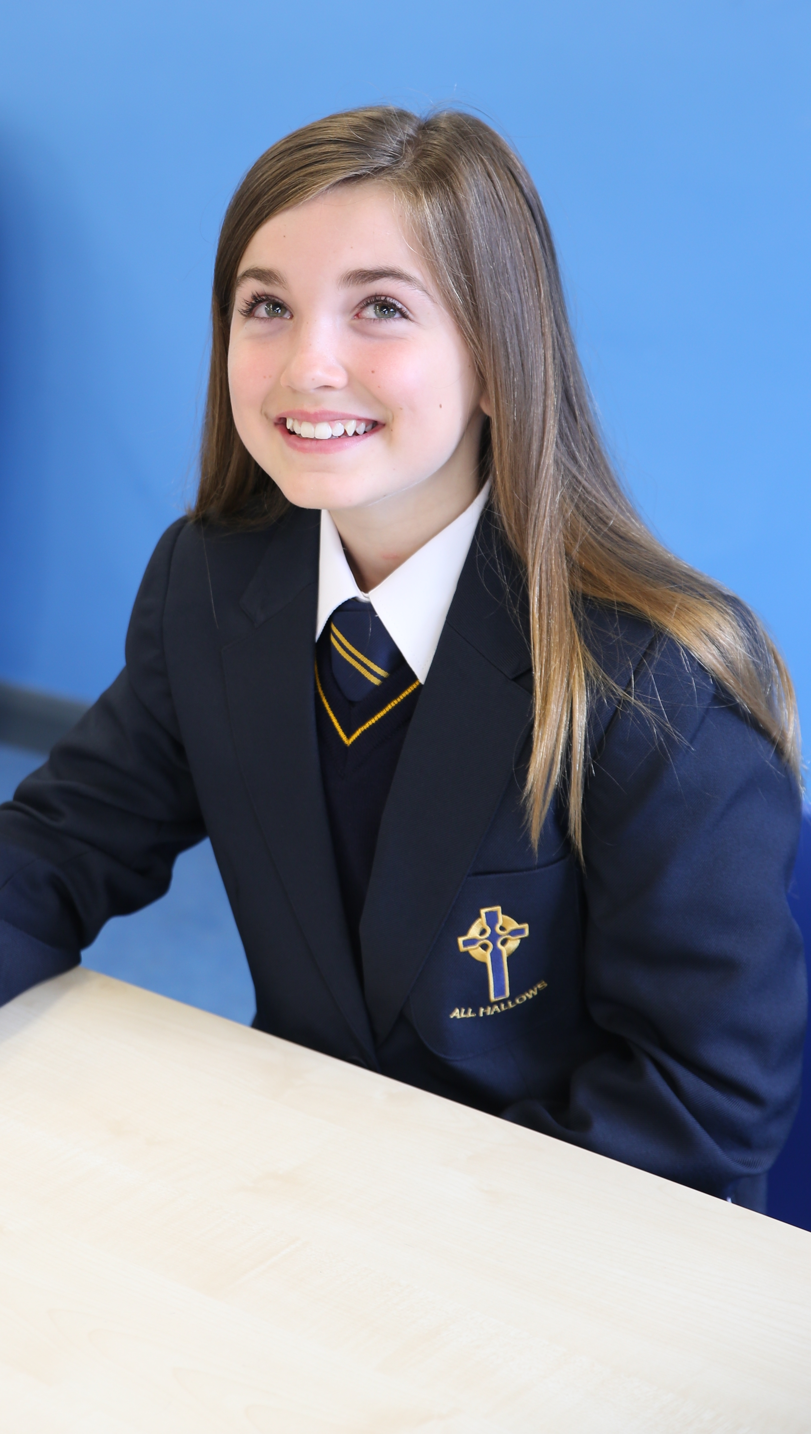
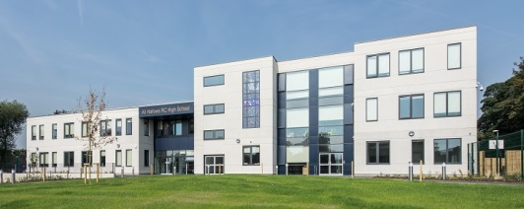

MISSION STATEMENT

We aim for All Hallows RC High School to be a Catholic school to which
children wish to come, to which parents wish to send their children,
and where teachers wish to teach.

Our Mission is to offer a high quality Catholic education for
all, in an environment where Gospel Values are central to teaching
and learning, and in which the unique value of each person
is recognised and respected.

Gospel Values are what Jesus said, what Jesus did and what Jesus told us to do,
so we will:

- Provide a safe, supportive and pleasant environment with a warm and welcoming atmosphere where all are supported, valued and respected.

- Live the Gospel values of life and truth, love and service, justice and peace, forgiveness and reconciliation.

- Provide a personalised curriculum with the highest quality of learning and teaching.

- Equip pupils for life-long learning and enable them to develop their full potential and sense of self-worth in preparation for their journey of life, knowing that God walks with them each step of the way.

- Recognise that everyone is unique and celebrate their differences.

- Create a community which promotes tolerance, respect and sensitivity to the needs of others so that pupils realise their duties and responsibilities to their neighbour as well as their personal rights and freedoms.

PARENTS’ A-Z GUIDE

Introduction

When schools, parents and carers share information, everyone has a really good understanding of how they can help children to learn. Communicating with each other and sharing information enables you, your child and the school to work together as partners in your child’s education.

The better the information you receive and the more information you can share with the school, the better you can support your child’s learning – and so can the school, helping your child to feel confident, happy, and so improving his or her chances of success.

Making the school aware of many things you know about your child and what they are doing out of school can be helpful. Teachers will be able to build on your child’s wider experiences and skills when he or she is at school.

This handbook is divided into three sections:-

- Practical Information

- Pastoral Information

- Curriculum Information

Practical Information

ABSENCE

If your child is absent from school you must contact All Hallows every day of your child’s absence. Please ring our Reception on 0161 921 1900. When your child returns to school they must bring a note from home, addressed to their form tutor explaining why they have been away. Attendance is very important at All Hallows, we monitor it very closely. Holidays are not permitted during school time unless there are exceptional circumstances.

ATTENDANCE AND PUNCTUALITY

It is very important that your child arrives on time to school. On the rare occasions that they arrive late, their form tutor will mark them present but late from 8.30 – 8.55am. If your child is very late for school - after
8.55 am they must report to Reception.

We operate a strict late gate. Any pupil late after 8.30am will receive a same day 30 minute after school detention. Parents/carers are informed of this detention via text message.

Registers are taken at the start of lessons in the morning and afternoon. Registration is used for a variety of reasons, which include Fire Safety, Truancy, Government legislation and internal school reports. The school now also operates a lesson by lesson registration scheme.

Regular attendance is essential to a pupil’s progress and except in cases of illness, pupils must not be kept away from school. Holidays are not permitted in school time.

BUS PASS

Children aged 11 to 16 need an igo pass to pay the concessionary fare on buses in Greater Manchester.
We have a supply of application forms at our School Reception. You can also download the form at http://igo.tfgm.com or collect one from a Travelshop at a main bus station in Greater Manchester.
You should receive your igo pass by post within 10 working days. Please do not return to school as we do not process these applications. Please see Section G of the application form for payment details.

CAR PARKING

Please do not drive into the school grounds between 7.45 - 8.30am and 2.45 - 3.30pm. Physically able students must not be dropped off or picked up from school premises. As this can cause health and safety concerns for other students

There are two visitor parking bays outside the main Reception which can be used if you are entering the school to speak to a member of staff or have a scheduled meeting. You should not park on yellow lines or make “U” turns in the entrances; please park considerately and do not block disabled access or obstruct residents access to their property.

CYCLING

The school actively encourages cycling and provides covered bicycle storage. Bikes must not be ridden on school grounds and a bicycle lock is recommended.

CONTACTING STAFF

Messages can be left at Reception and these will be distributed to staff regularly throughout the day. In case of emergency the relevant person will be contacted immediately. Please note that due to teaching commitments, staff are not usually able to respond immediately. The school also uses ‘Parentmail’ to contact home so it is very important that we have your up-to-date mobile phone number and email address. The Form Tutor is the first point of contact for all non-curriculum concerns.

DISCIPLINE

The school has a system of Rewards and Consequences, details of which are displayed in every Form Room.
If your child behaves in a sensible manner and works to the best of their ability, they will not face any sanctions. Your child must follow the classroom responsibilities. These are displayed on each classroom wall.

Rewards

Recognition/Achievement points will be given by teachers to reward good work, effort, behaviour and attendance. Pupils can also gain extra recognition/achievement points for attending extra-curricular clubs and activities.

Teachers may issue a stamp in the pupil planner, which are checked daily by form tutors. A tally will be kept on display in the form room of the number of recognition/achievement points earned by pupils.

Consequences – C3s

C 1 CHANCE – Your child’s teacher will give them the chance to improve their behaviour/attitude to learning.

C 2 CHOICE – Your child’s teacher will give them the choice to improve their behaviour/attitude to learning.

C 3 CONSEQUENCE –

If your child chooses to continue with poor behaviour they will receive the consequence of –

- Being removed from their lesson, and

- A 30 minute detention at 3pm. This will occur with the subject teacher on the same day. This is a non-negotiable detention. As a courtesy parents will be sent a text, so it is important we have up to date contact details.

Teachers may keep your child in to do extra work or a detention during the breaks and lunch time, or after school, or they may set them extra work to do at home.

If your child is often in trouble, they may be given a detention if they get to the ‘Choice’ level.

This C3 system is also in use out of lessons, on the yard and corridors.

We feel sure that your child will not want to cause you such anxiety and we expect them to explain fully what happened. If your child consistently goes up the C3s they will be put on a yellow (1st Stage) or a red (2nd Stage) subject report card.

Finally, for those people who continue to misbehave, a Conduct Report will be given every day for a period of time. These pupils will have to get it signed, each lesson, by the teacher to show how they worked and behaved in the class. Each evening the report is to be signed by parents and the report must return each day with your child. If your child is on a conduct report it may be necessary to have a meeting with you in school to discuss our concerns.

EMERGENCY CLOSURE

In the unlikely event of school closure due to heavy snowfall or some other unforeseen occurrence, it will be announced on: The School Website, Twitter, the LA website and on local radio stations.

The school telephone will also have a message informing callers about closures and the school website will display a “flash” message. The information will also be relayed to parents using the Parentmail system by email/text message.

EQUALITY

The school supports the Equality Act 2010 and we strive to make all our procedures compliant with the Equality Duty. Downloads of policies are available from the school website.

FINANCIAL SUPPORT

If you are in receipt of Income Support or certain other allowances, there may be an entitlement to free meals, travel etc. Details are on your local council website. If you are entitled it is always worth applying. Your child is entitled to a meal and a drink. Even if your child prefers to bring a packed lunch if they are on our free school meal list they can use their ticket to obtain just a drink, fruit or sandwich if they forget to bring their lunch into school.

If you are entitled to free school meals we would ask that you do apply as schools receive a ‘pupil premium’ for each eligible child which the school can spend on useful resources.

FIRST AID

If your child becomes ill or is injured during the day, the school First Aiders will make a judgement about their condition. A short period of rest may be all that is required. If it is considered necessary to send your child home, you will be asked for them to be collected from school.

Medicines should only be brought into school when essential. Please contact the Office for a form to authorise this. Please mark all medication clearly with your child’s name and form.

If your child has to regularly take medication, you should inform us as we have strict routines to follow. Please contact the School First Aiders at Reception in the first instance..

FOOD AND DRINK

The school has a single area catering facility which is available at break and lunch times. The school canteen is open from 7.45am for breakfast.

Menus are displayed in the dining area. A wide selection of choice is available. Pupils may bring their own packed lunch if they prefer and may eat with pupils buying a lunch. Drinking water is available in various areas around school. Pupils should bring their own water bottle. Chewing gum is banned from school and only water can be brought into school and must be kept in their bag. (No fizzy or energy drinks).

The school has in place a biometric identification system which uses the finger and its image to uniquely identify each pupil and member of staff. The system measures many aspects of the finger to do this. Each pupil has their fingerprint registered, which will then be translated into a unique identification code which is entered into the system. The system does not create or store an image of the fingerprint.

The biometric system removes the need for pupils to carry cash and enables the quick and efficient processing of pupils through the canteen. Money is held in your child’s own account which can be topped up by them in school or securely by you via our Parentmail online system. This also means that pupils eligible for free school meals are also no longer distinguishable from other pupils, therefore removing any awkwardness associated with their entitlement.

FOOD TECHNOLOGY RESOURCES

The school asks the parents of every child to make a donation towards the cost of food technology resources and ingredients for practical lessons. This saves you from having to buy ingredients for each lesson. For 2018/19 the sum that will be requested is £21. This ensures that your child can take part in all practical lessons. You can opt to provide your own ingredients. You will receive further information over the summer.
This payment is requested in advance of the start of lessons to allow us to plan and make ready resources. Parents who have not paid by the date notified will be expected to provide their own ingredients.

GOVERNORS

The school is supported by an active Governing Body, made up of parents, staff and members of the local community, who hold regular General and Committee meetings. Please see the school website for more information.

HOLIDAYS / UNAUTHORISED ABSENCE

We would like to explain to all parents the law regarding absences during term time. Unless there are exceptional circumstances, all requests for holidays will be turned down. If parents still decide to take their children out of school, then we have no choice but to mark the absence as an unauthorised absence which may lead to the involvement of the Education Welfare Service and the issuing of a Fixed Penalty Notice, the cost of which is £60 if paid within 21 days rising to £120 per parent, per child.

If the Fixed Penalty Notice is not paid, legal action will be taken by the Local Authority. These Fixed Penalty Notices have been introduced as part of the government’s drive to improve attendance.

If you need to take your child out of school for a special event (e.g. Family Wedding) please request in writing, using the form available from Reception, well in advance.

Please return to Reception for consideration by Mrs Done (Assistant Headteacher) or Mrs Bartley (Social Inclusion Officer) and the relevant Head of Year.

HOME SCHOOL AGREEMENT

All Hallows RC High School will:
- Bring pupils to an awareness of the presence of Christ in themselves, in others and in the world around them. Developing good and practising Catholics in a Christian community by using the example of the life of Christ in ways which make it as relevant and meaningful as possible.

- Provide an ordered, caring and supportive environment which celebrates diversity and equality. We will also provide for the academic, social, physical and personal development of each individual and so helping pupils to enjoy school, so that they feel valued and appreciated as individuals.

- Foster academic excellence through a curriculum which is flexible and relevant to pupils at different ages and stages of development.

- Develop a consistent system of assessment which will allow pupils to measure and monitor their own progress.

- Set challenging but achievable targets for each student and provide parents/carers with records and information about their child's educational progress and general development.

- Give parents/carers regular opportunities for meetings with teachers and be available at other times when concerns or questions arise.

- Pass on medical and educational information that parents/carers provide where appropriate.

- Keep parents/carers fully informed about important school matters through letters home, text messages, the school’s website, the newsletter and their child’s planner.

- Efficiently and effectively respond to parents’/carers’ enquiries promptly and justly.

- Implement and maintain a high standard of behavioural attitudes and conduct.

- Develop sound and effective policies for the management and control of school resources.

PUPIL RESPONSIBILITIES:
I will:
- Attend school regularly and on time.

- Wear school uniform correctly and with pride and bring all the equipment I need every day.

- Take care of all school equipment and help keep our school free from litter.

- Be polite and show consideration and respect for others in school.

- Observe the school rules and behave sensibly.

- Complete classwork and homework to the best of my ability and show a good positive attitude towards my learning.

PARENTAL RESPONSIBILITIES:
We accept that we as parents are the primary educators of our children and have an irreplaceable role to play in supporting our children’s learning at school.

As parents/carers I/we will:
- Ensure that my child attends school regularly and maintains a good attendance rate and arrives on time, providing school with a note to cover any absence and recognising the incurrence of a fine for term time holidays.

- Ensure that my child wears full school uniform in line with school policy and takes pride in their appearance.

- Ensure my child has all the necessary equipment and kit every day to take part in the life of the school.

- Inform the school of any concerns or problems that might affect my child’s work or behaviour.

- Support the Christian values of the school community.

- Support all the policies and strategies that the school uses to keep a positive working atmosphere.

- Give my child opportunities for home learning and support homework from school.

- Encourage my child to be positive about all aspects of school, including homework and the many other opportunities offered.

- Support the school’s policies and guidelines for behaviour.

- Attend parents’ evenings and discussions about my child’s progress.

- Encourage my child to show kindness and consideration to others.

- Talk to my child about his/her experiences in school and encourage his/her to do his/her best.

- Attempt to support the Catholic community and the school governors in their responsibilities for maintaining the school buildings in good repair.

HOME SCHOOL COMMUNICATION

The school uses “Parentmail” which means we can send an email or text message to you informing you of letters being distributed, forthcoming events or important details. It is most important therefore, that we have both parental email and especially mobile phone numbers.

The school will only send a communication via the oldest sibling in cases of a “whole school” letter.

LOCKERS

School has a limited number of available lockers which are available to pupils at a cost of £10 is required. These lockers are prioritised for years 7 and 11 however this does not mean a locker will always be available All lockers must be emptied at the end of the summer term or they will be cleared during the holidays. Pupils must not access lockers during form or lesson time.

LOST PROPERTY

Property that is identifiable will be returned to the pupil. Pupils should ask at Reception if they have lost an item, somebody may have handed it in. Remember it is easy to identify property if it is clearly labelled with the pupil’s name.

LUNCH TIME

Pupils are required to remain on the school premises all day including lunchtime. If there are exceptional circumstances that necessitate a child going home for lunch, a meeting must be held between parent and PPL to discuss this.

MEDICAL / DENTAL APPOINTMENTS

These appointments must be made after school unless there are exceptional circumstances. If you know in advance that your child will be absent they must:

- Inform their form teacher of the appointment and show the appointment card/letter. He/she will sign your red card.

- Show the subject teacher their red card and ask to be excused in good time.
- Sign out at Reception when they leave school.

- Sign in again when they return. If the appointment is early morning, before school commences, pupils are to sign in at the office when they arrive in school.

NB: Pupils are expected to attend school before/after medical appointments and not to take the whole day off.

MOBILE PHONES, MUSIC PLAYERS, JEWELLERY

Mobile phones are not allowed in school. In emergencies contact between home and school can be made via Reception. Try to make arrangements before your child leaves home.

Parents must not contact pupils on their mobile phones during school time. Any phones that can be seen or heard will be removed from the child and held at Reception.

Only small studs and a watch are allowed in school. All such items are brought into the school at owners risk and the school cannot accept responsibility for any loss or damage.

ONLINE PAYMENTS

The school has an online payment system through ‘Parentmail’ for Lunches, Trips/Books etc., which enables you to pay for these items via a secure website. School is a cashless environment and appreciate your support in this matter.

OPENING HOURS

The school is open to pupils from 07.45 to 16.00. These hours are extended for some if a specific activity is taking place. Your child should not be in any part of the school unless supervised by a member of staff.

PARENTMAIL

We use Parentmail to stay in touch with you and pass you important information about your child via text and email. You can use Parentmail to pay for trips, events, food technology resources, music lessons etc. You will receive an invitation to join Parentmail in September.

Parentmail can also be used to top up your child’s dinner money; you can then log in and see what food choices they are making at school.

PLANNERS

Your child will be given a new planner on their first day in September by their form tutor.

Your child must have their planner and timetable with them every day to record homework. At the end of each week parents are asked to check their child’s planner and sign it. Your child’s form teacher will check their planner to make sure it is filled in.

QUESTIONS

Knowing who to speak to is confusing:

If it is an “admin” type query:
School Reception will deal with it or pass you on to the most suitable person.
If a query regarding your child’s learning:
The specific Subject teacher or the Form Tutor

Telephone contact can be made at any time but please be aware that due to teaching timetables, it will not usually be possible for you to speak to the teacher immediately.

The school also has a Complaints Policy. The Deputy Headteacher, Mr Fitzsimons is the Complaints’ Co-ordinator.

RELIGIOUS ACTIVITIES

All Hallows RC High School is a Roman Catholic school and observes and follows the Catholic faith. During form time pupils engage in reflection and/or prayer each day.

There are regular assemblies when pupils and staff come together to pray. Form classes will be given the opportunity to prepare the themes and the readings for these.

Special activities take place during the seasons of Advent, Lent and Holy Week.
Voluntary Masses take place in the Chapel each Thursday morning. See the ‘Chaplaincy Noticeboard’ for information and times. All pupils are required to join in with reflection and prayer and to be respectful of our beliefs and customs.

ROAD SAFETY

We urge all our pupils to act responsibly coming to and from school. It is very important that we treat our community and neighbours with respect.

Pupils should:
- walk quietly to and from school without disturbing our neighbours
- do not drop litter on the streets around school
- report any poor behaviour to your form tutor
- be respectful and quiet when travelling on public transport

SCHOOL DAY TIMINGS
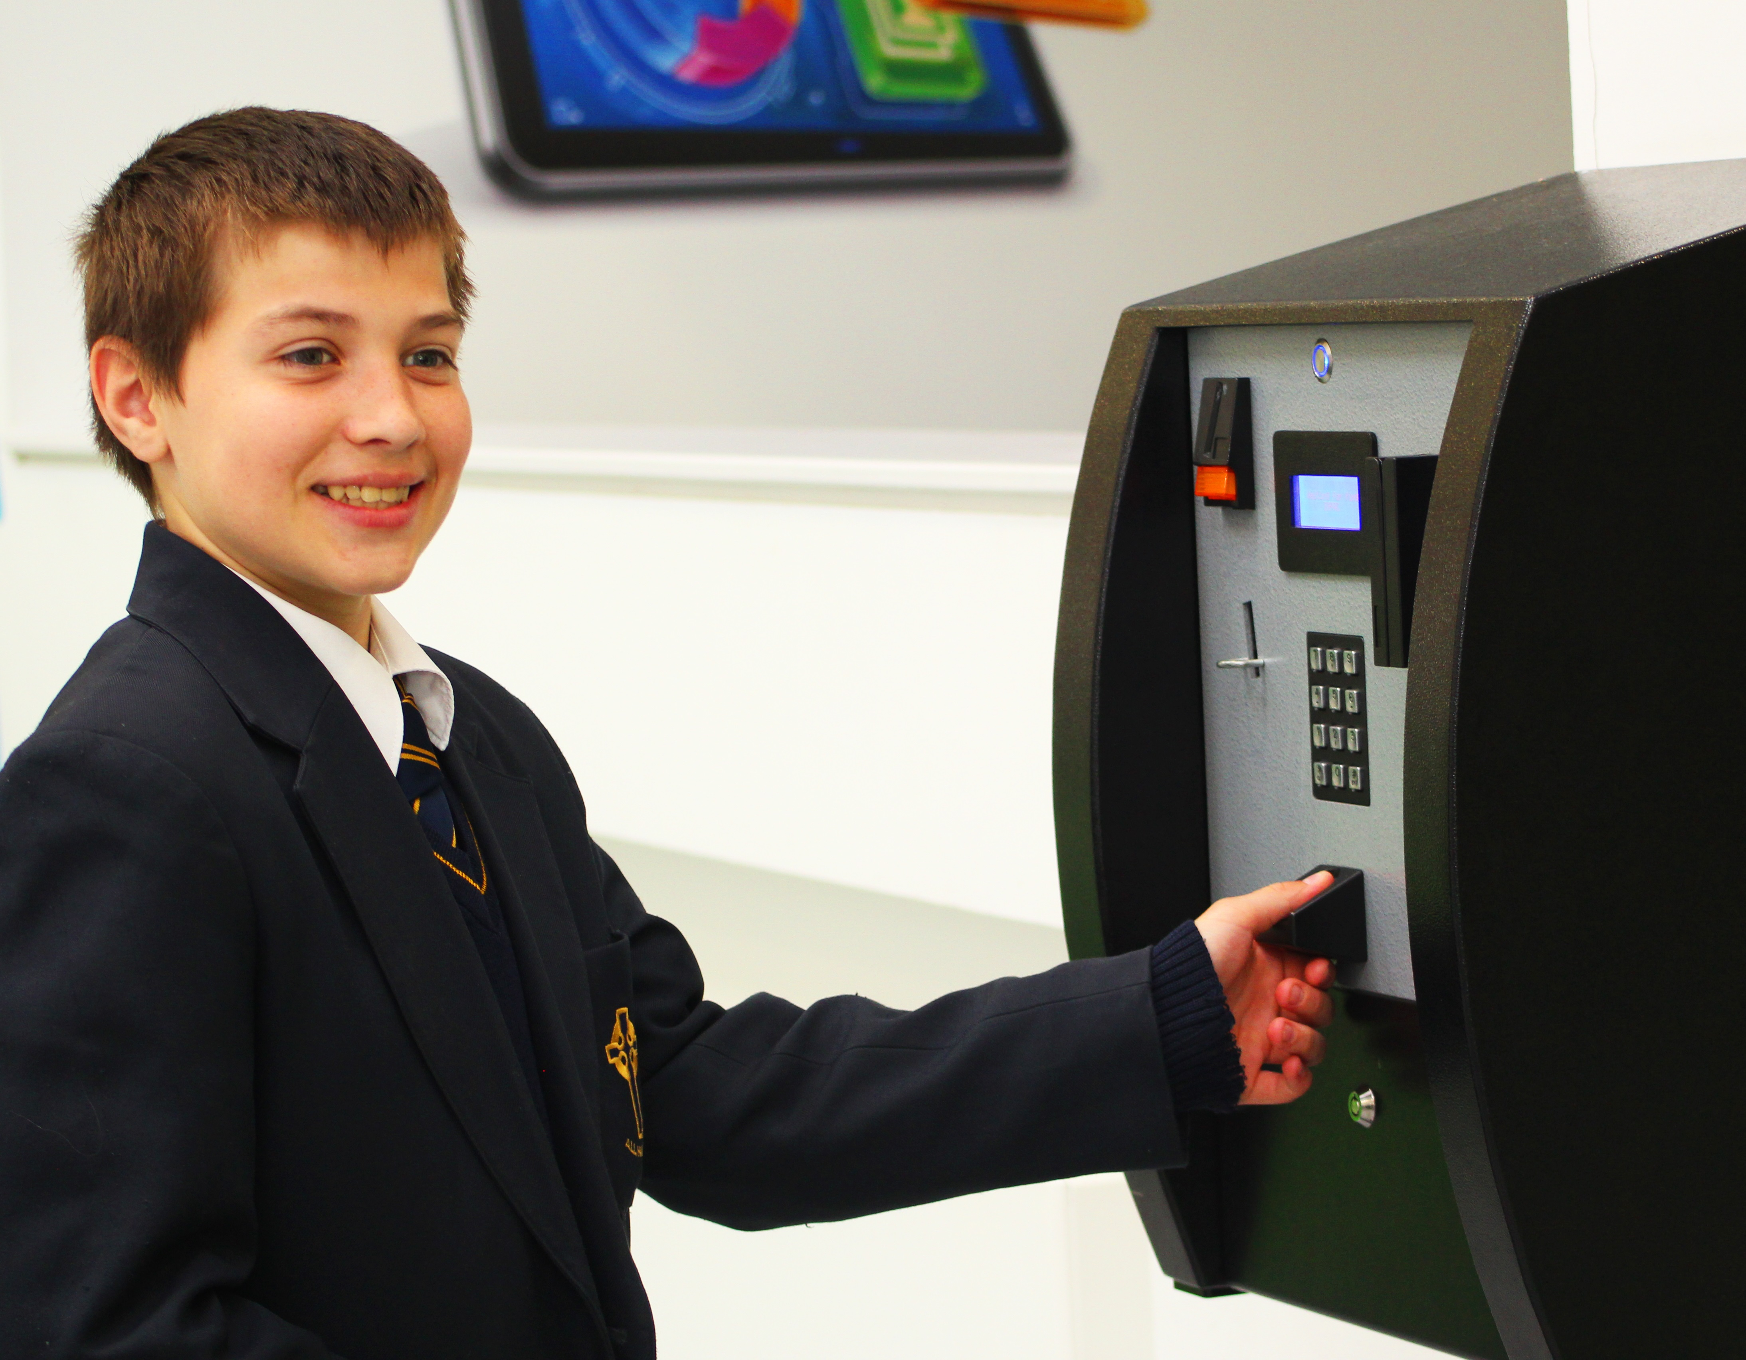
8.30 – 8.55 | REGISTRATION  Please make sure you get your mark
8.55 – 9.45 | Lesson 1
9.45 – 10.35 | Lesson 2
10.35 – 10.50 | Break
10.50 – 11.40 | Lesson 3
11.40 – 12.30 | Lesson 4
12.30 – 1.20 | Lunch
1.20 – 2.10 | Lesson 5
2.10 – 3.00 | Lesson 6

UNIFORM

School uniform must be worn by all pupils. This consists of:-

BOYS  School blazer  School jumper  Black tailored trousers.  White shirt and school tie  Plain black school shoes (no form of trainer/sports shoe is acceptable) | GIRLS  School blazer  School jumper  Black knee length skirt or  black tailored trousers  White shirt and school tie  Plain black school shoes (no form of trainer/sports shoe is acceptable)  Plain black or white ankle socks or black tights
The following is available from Whittakers Schoolwear (formerly Wilkinsons),
123-125 Chorley Road, Swinton, M27 4AA. Telephone: 0161 794 1396.

- Blazers
- Jumpers
- Ties

All pupils are expected to wear the school PE KIT which is available from Whittakers and consists of:
- A Royal Blue Dri-Fit shirt for both boys and girls,
- Navy shorts and
- Royal Blue football socks.
PE Kit for Year 7s on entry is free of charge; the cost for replacement or additional items is the responsibility of the parent/carer.

HAIR

Must be one natural colour; extreme hair styles must be avoided. Students who attend school with coloured or shaven styles will be placed in seclusion and may be sent home. Hair accessories should match school colours.

YOUR CONTACT DATA

Please keep the school office informed of changes to personal data – address, phone contacts, email, doctors, medical conditions etc. YOU can update personal information via Parentmail or the Parentmail App.

Pastoral Information

BULLYING

The school has an Anti-Bullying Policy and does not condone any form of bullying. If you suspect your child is being bullied, please contact the Form Tutor for an initial confidential discussion.

CLUBS

There are a number of lunchtime and after-school clubs; information is displayed in Form Rooms.

OTHER USEFUL INFORMATION

Letting your Form Tutor know about what your child is doing out of school can also be useful. Teachers will be able to build on your child’s experiences and skills when at school e.g. hobbies and sports, achievements, unexpected changes, illness or bereavement.

PARENTS EVENINGS

These events provide a good opportunity to find out how your child is settling in and to ask teachers what you can do to help.

Parents’ Evenings are held for each year group in the school, when all subject teachers and Form Tutors for a particular year group should be present.

The car park at the rear of school is open for additional parking on Parents’ Evenings.

RESPONSIBLE USE OF INTERNET

As part of the school's development of ICT skills, we offer pupils supervised access to the Internet. Pupils will eventually be able to exchange electronic mail with partner schools and research information from museums, libraries, news providers and suitable Web sites as part of their programme of learning.

Before being allowed to use the Internet, all pupils must obtain parental permission. Please see the Rules for Responsible Internet Use which is operated by school. The school would ask that you and your child read and then complete the permission form as evidence of your approval and their acceptance of the school rules on this matter.

The nature of the internet makes it difficult to monitor information but the school does its utmost to ensure all information accessed is safe and appropriate. The school operates a filtering system that blocks access to known inappropriate materials. All our screens are in public view and, as stated above, access is supervised. Moreover, positive steps are constantly being taken to address any concerns / issues.

SCHOOL COUNSELLOR AND SUPPORT

The school employs a counsellor who is in school 2 days each week to support any pupils who are struggling emotionally in or out of school. Referrals are made in consultation and agreement with parents or carers.

SCHOOL TRIPS

The school recognises the importance of these events whether curriculum related or not. A variety of trips are organised each year and information regarding each one is sent home individually.

New Year 7 Parents are also asked to complete and sign Form C1 which covers your child for all out of school activities during their time at All Hallows. This reduces the amount of bureaucracy in obtaining this for each trip. You will receive this form with other pre-joining information.

SETTLING IN

During the first weeks of being with us your child will get to know their Form Tutor. This is the person to whom they should go if they are experiencing any difficulties. You can help your child settle in quickly by talking to them about school and by checking their Planner every day. This will assist them in organising themselves fully for each school day.

TRUANCY

Pupils are obliged by law to attend school for 190 school days per year. Any parent who does not see that this obligation is fulfilled can ultimately be taken to court for the omission. The school plays its part in seeing that the law is obeyed by having a structured system of registration. In addition, all subject teachers keep a class register to double-check that pupils remain in school throughout each day.

Curriculum Information

HOMEWORK

Homework to be completed is recorded in Pupil Planners. The Homework Policy is on the website

MUSIC LESSONS

Extra-curricular instrumental tuition on a range of instruments can be organised by the school. You should contact Mrs Hannaford, Head of Music for further information regarding timings and costs, an information letter is included in your pack.

PLANNERS

These are used for communication between school and home:

Pupils – to record homework/attendance and punctuality details.
Teachers – for comments of concern or notes of praise/good work.
Parents – to write comments/concerns and to sign the Planner weekly.

REPORTS

Your child will receive reports about their attainment and progress at several points during the year.

In Conclusion

Thank you for taking the time to read through this booklet. Please do let us know if there is anything you feel we have missed, or if anything needs more careful explanation. Email to: allhallows@salford.gov.uk Further information on school and curriculum can be read on our website https://www.allhallowssalford.com

All Hallows RC High School
Specialising in Business, Enterprise & Sports

150 Eccles New Road
Salford
M6 8AA

Telephone: 0161 921 1900
Email: allhallows@salford.gov.uk
Website: www.allhallowssalford.com

Headteacher: Mrs A Cavanagh

